

UNIVERSITY OF AZAD JAMMU & KASHMIR
Department of Software Engineering
Software Configuration Management Technologies (SCMT)

Lab No.7

Submitted by | - Name: Rizwan Ali  - Roll No: 2025-SET-40
Submitted To | - Eng. Fahad Nisar
Degree Program | - BSc Software Engineering Technology
Submission Date | - 8 June 2026

Lab Objective: Creating and Merging a Pull Request on GitHub

Step 1. Open a Pull Request

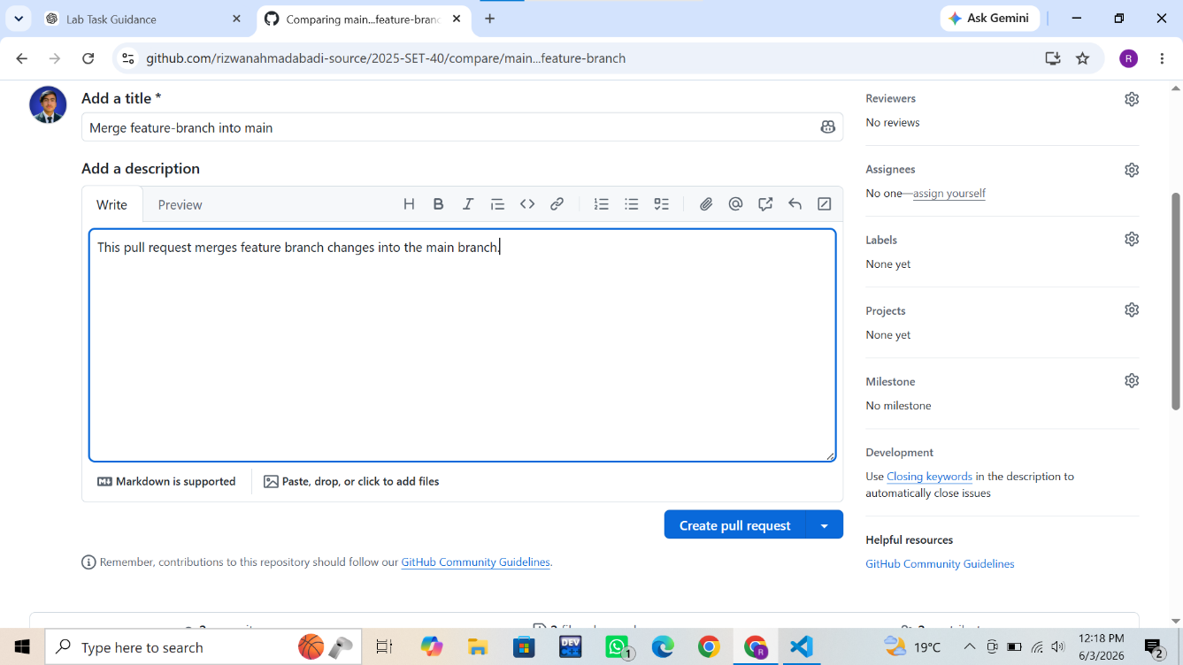
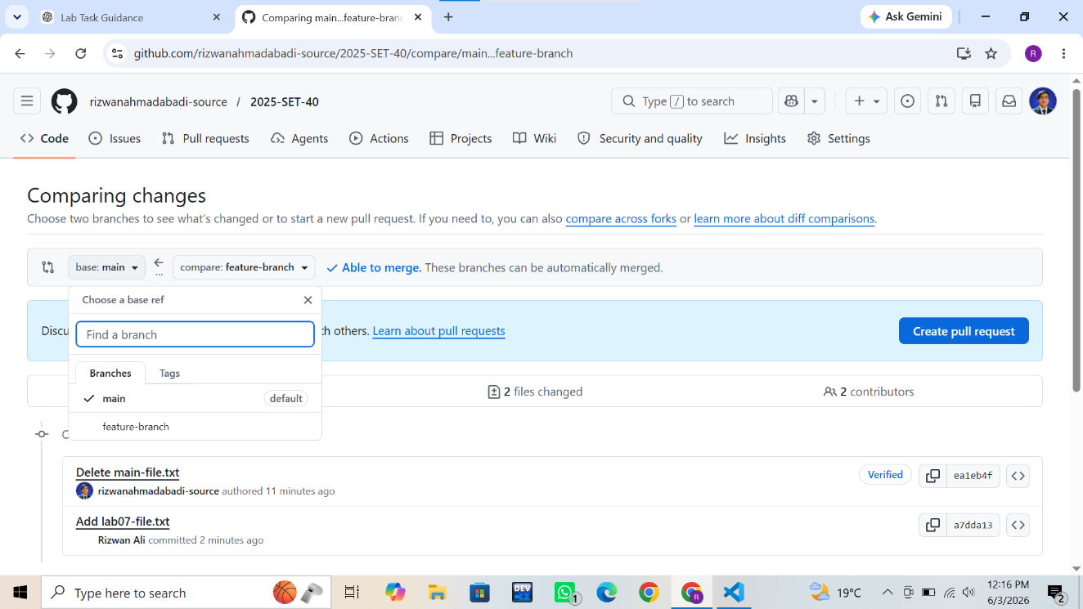
In this step, I opened my GitHub repository and created a new pull request. The base branch was selected as main and the compare branch was selected as feature-branch. After adding a title and description, I created the pull request.

Action Performed:
- Opened GitHub repository
- Selected main as base branch
- Selected feature-branch as compare branch
- Created a new pull request

Step 2. Review for Merge Conflicts
n this step, GitHub automatically checked for merge conflicts between the branches. Since both branches contained different files, GitHub displayed a message indicating that there were no conflicts and the pull request could be merged safely.

Action performed:
- Reviewed pull request
- Checked merge status
- Verified that no conflicts existed

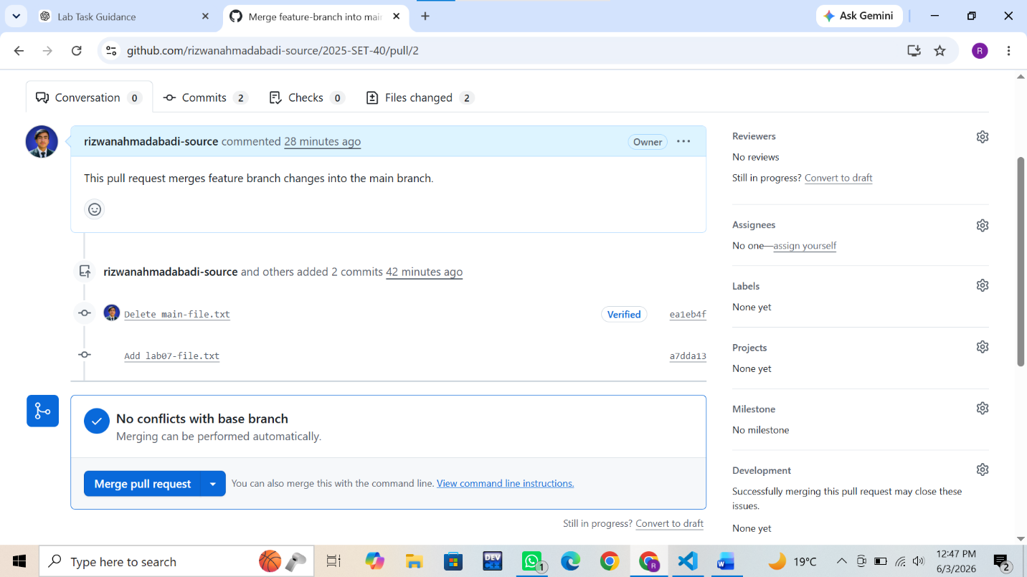

Step 3. Merge the Pull Request
In this step, I merged the pull request by clicking the Merge Pull Request button and then confirming the merge. GitHub successfully merged the changes from feature-branch into main.

Action Performed:
- Clicked Merge Pull Request
- Confirmed merge
- Successfully merged changes into main branch

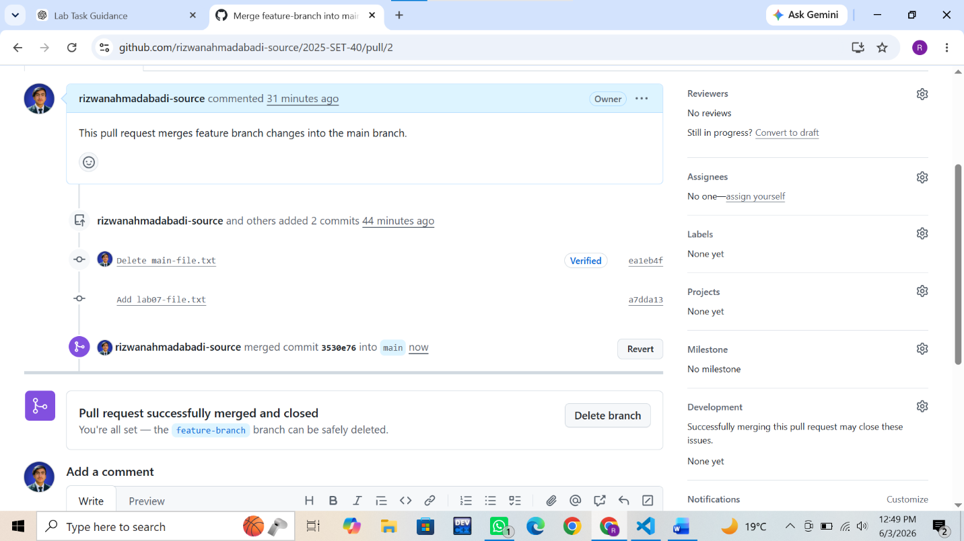

Step 4. Verify merge
In this step, I navigated to the repository's Code tab and switched to the main branch. I verified that both main-file.txt and feature-file.txt were present, confirming that the merge was successful.

Action Performed:
- Opened main branch
- Verified merged files
- Confirmed successful merge

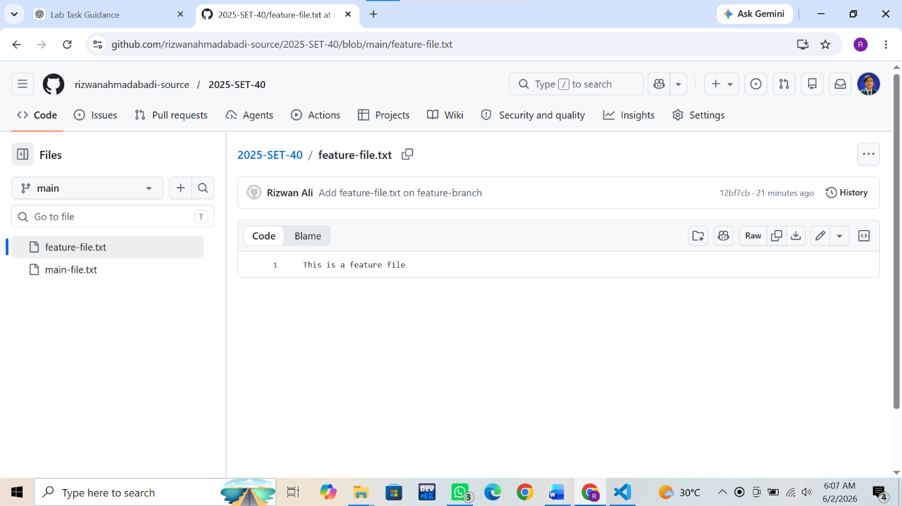

Conclusion
Through this lab, I gained hands-on experience with the complete Pull Request workflow in GitHub. I successfully created and reviewed a pull request, verified merge compatibility, and merged branch changes into the main branch. This exercise improved my understanding of branch-based development, code integration, collaboration workflows, and effective version control management using Git and GitHub.

